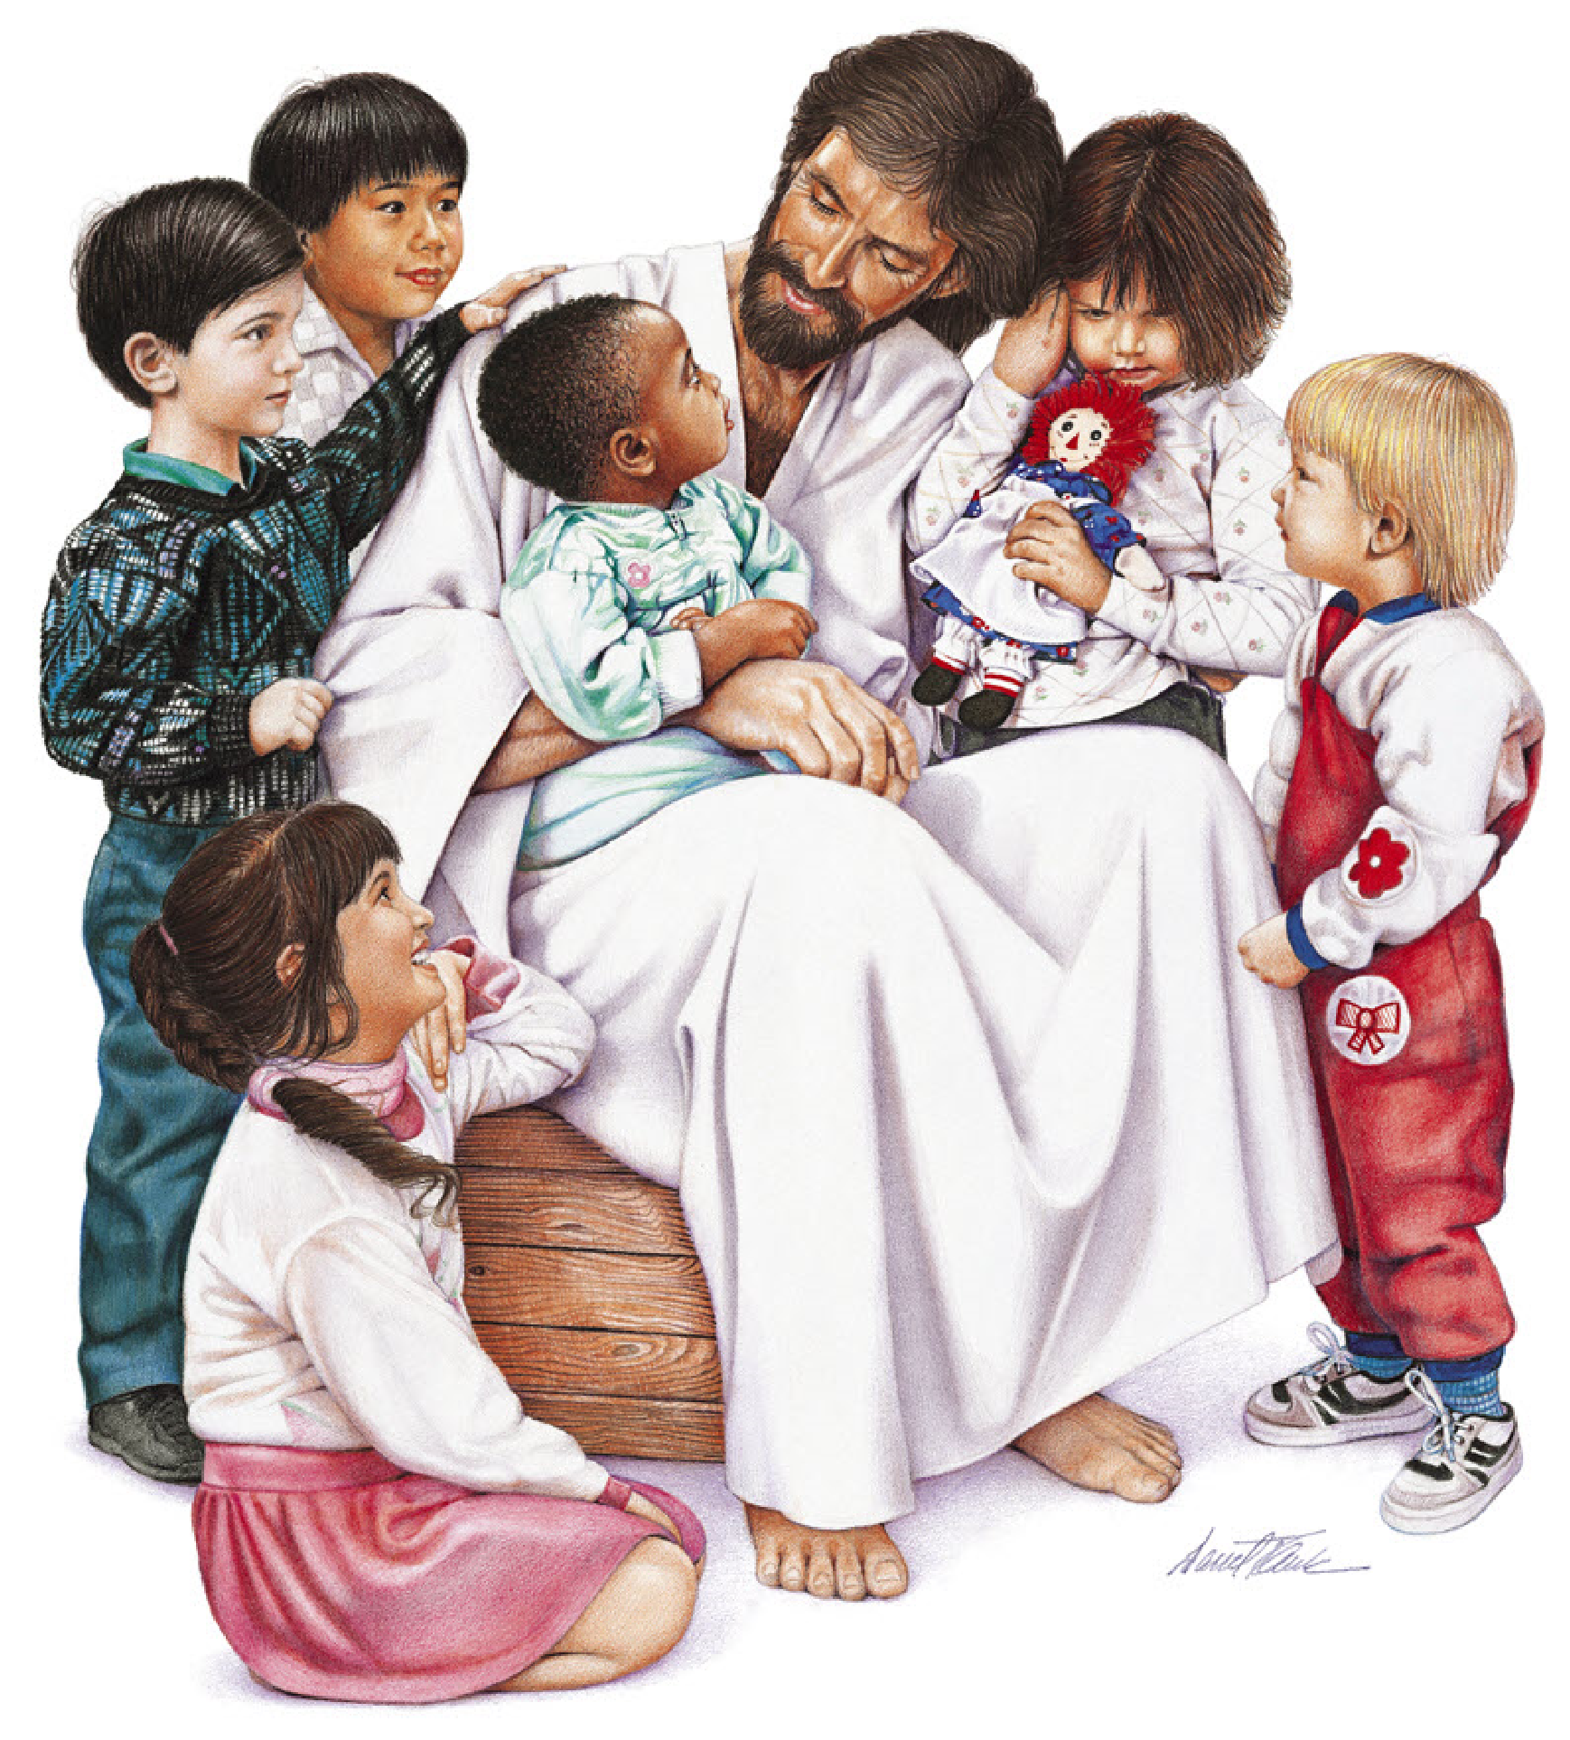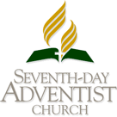
Tariro Thelma & Godswill Siyawamwaya
Lael Levi Siyawamwaya
21st October
Wakefield, England
Sabbath 6th June
26
25
Fredrick Nti-Mensah
Wakefield
Bring them up in the nurture
and admonition of the Lord
EPHESIANS 6:4
This certifies that
__________________________________
Child of
__________________________________
Born_________________________ ____
at________________________________
was presented to the Lord in dedication
on ___________________________ ____
at _____________________ SDA Church
Pastor(s) __________________________
______________________________
They brought unto Him also infants, that He would touch them:…Jesus called them unto Him, and said,
Suffer little children to come untoMe, and forbid them not: for of such is the kingdom of God.
LUKE 18:15, 16.
20
20

